Figure 2. Soil basal respiration (BR) of soil under five crop sequences (I, II, III, IV and V), three sampling depths (0-5cm, 5-10cm and 10-20cm) and three sampling seasons: a) summer, b) autumn, c) winter. Note the difference in scale of the y axes.
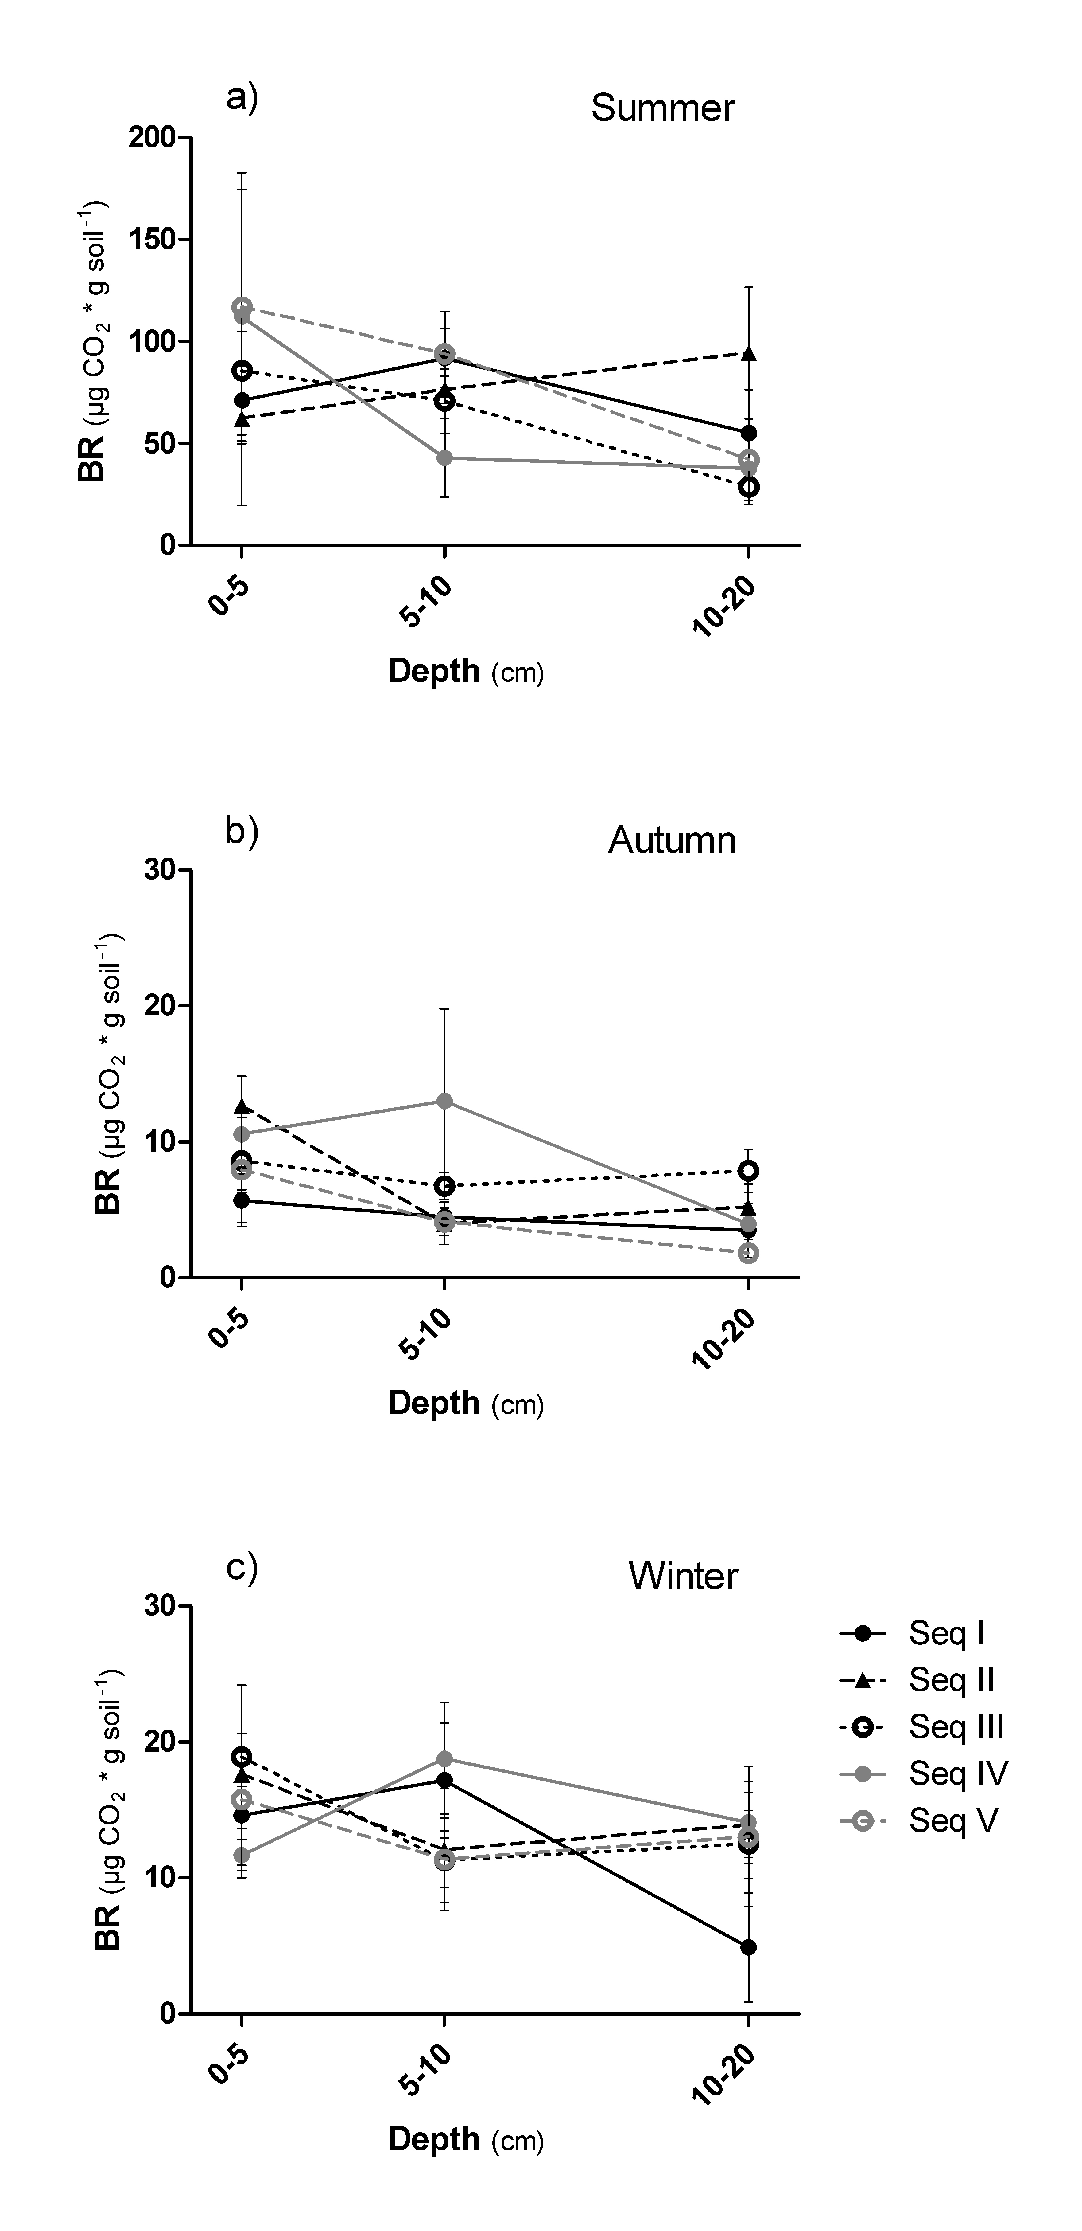
Sequences. Seq I: Single crop per year: Sunflower- Wheat-Sorghum-Soybean-; Seq II: Mixed agriculture/livestock with pastures: Wheat-Sorghum-Soybean-Canola-Pasture, Seq III: Winter management: Wheat-Canola-Barley-late Soybean, Seq IV: mixed with annual feed crop: Wheat-Oat/Vicia-Sunflower; Seq V: Intensive management: Wheat-Barley-Canola, Soybean or late Soybean.

