Raman spectroscopy
Raman spectra were acquired in a Renishaw In Via reflex system equipped with charge-coupled device (CCD) detector of 1040x256 pixels. A 514 nm diode laser (50 mW) was used as excitation source in combination with a grating of 2400 grooves/mm and slit openings of 65 µm, which yield a spectral resolution of about 4 cm⁻¹. The laser power was kept to 100%. A 50X (0.5 NA) long working distance (8 mm) Leica metallurgical objective was used in the excitation and collection paths. Spectra were typically acquired in 10 seconds with 2 accumulations.
Imagenes obtenidas con el microscopio Raman, que permiten visualizar las zonas donde se tomaron los espectros.

Grafito Comercial
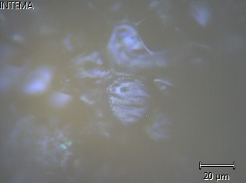
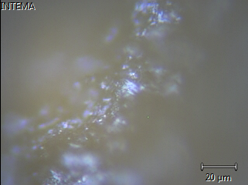

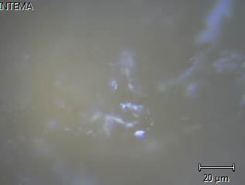
800 600
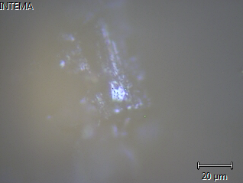

400
