Supporting information
Optimized Hop Extracts Inhibit Paenibacillus larvae Without Toxic Effects on Honey Bees
Fuentes Giselle^{a,b}; Iglesias Azucena^{a,b}; Mitton Giulia^{a,b}; Orallo Dalila^{c}; Chaparro Mauro^{e}; Ramos Facundo^{a,b}; Maggi Matias^{a,b}; Ramirez Cristina^{c}; Fuselli Sandra^{a,d,}.
Corresponding autor: Fuentes Giselle. gisellefuentes07@gmail.com
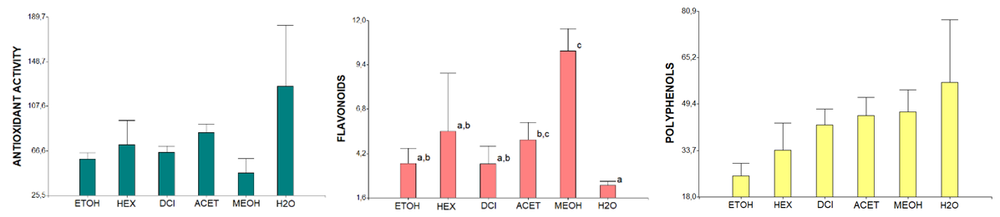

Figure S1: Bar graph indicating average values of total polyphenol content expressed as mg gallic acid equivalents (GAE)/g extract (p value: 0.290), antioxidant activity expressed as mg equivalents of TROLOX per g (p value: 0.288), and total flavonoid content expressed as mg quercetin equivalents (QE)/g of extract. (p value: 0.037; different letters indicate significant differences) in the extracts according to the type of solvent used. ETOH (ethanol); HEX (hexane); DCL (dichloromethane); ACET (ethyl acetate); MEOH (methanol); H2O (water).

