**Supplementary Material for**

**Organic vs. conventional farming: do they shape the genetic structure of wild rodent populations in agroecosystems?**

**Tables S5 to S13**

**Figures S1 to S10**

**Table S5**: Population genetic statistics for rodent populations from border habitats in conventional and organic farming. AVC: Altos Verdes, conventional farming; AVO: Altos Verdes, organic farming; LGC: Las Gaviotas, conventional farming; LGO: Las Gaviotas, organic farming; DH: Dos Hermanas, organic farming.

|  |  |  |  |  |  |  |  |  |  |  |  |  |
| --- | --- | --- | --- | --- | --- | --- | --- | --- | --- | --- | --- | --- |
|  |  | Neutral Data set | | | | |  | Selected data set | | | | |
|  |  | AVC | AVO | LGC | LGO | DH |  | AVC | AVO | LGC | LGO | DH |
| *Calomys*  *laucha* | Private alleles | 1638 | 2352 | 2043 | 1424 | - |  | 1 | 6 | 2 | 2 | - |
| Ho | 0.084 | 0.094 | 0.093 | 0.079 | - |  | 0.106 | 0.115 | 0.126 | 0.032 | - |
| Mean HL | 0.861 | 0.842 | 0.843 | 0.874 | - |  | 0.797 | 0.855 | 0.767 | 0.977 | - |
|  |  |  |  |  |  |  |  |  |  |  |  |  |
| *Akodon*  *azarae* | Private alleles | 1131 | 2144 | 2081 | 2071 | 1543 |  | 1 | 6 | 3 | 4 | 3 |
| Ho | 0.100 | 0.104 | 0.108 | 0.113 | 0.107 |  | 0.050 | 0.095 | 0.076 | 0.082 | 0.06 |
| Mean HL | 0.839 | 0.862 | 0.823 | 0.817 | 0.834 |  | 0.933 | 0.885 | 0.883 | 0.890 | 0.946 |

**Diagnostic statistics for observed heterozygosity (Ho) assessment models**

**Table S6:** Summary of the posterior parameter estimates from the Bayesian model for **neutral loci** in ***Calomys laucha****.* For each parameter, the posterior mean (estimate), standard error, and 95% credible intervals (CI) and the Gelman-Rubin statistic (R-hat), Bulk Effective Sample Size (Bulk ESS) and Tail Effective Sample Size (Tail ESS) are provided.

|  |  |  |  |  |  |  |  |
| --- | --- | --- | --- | --- | --- | --- | --- |
|  | **Estimate** | **Est.Error** | **95% CI** | **95% CI** | **Rhat** | **Bulk ESS** | **Tail ESS** |
| **Intercept** | -0.943 | 0.006 | -0.955 | -0.931 | 1.000 | 6724.207 | 8547.112 |
| **zi Intercept** | 0.522 | 0.004 | 0.514 | 0.531 | 1.000 | 10274.652 | 9600.325 |
| **organic management** | 0.0689 | 0.005 | 0.060 | 0.078 | 1.000 | 7934.802 | 8896.771 |
| **vg** | -0.568 | 0.015 | -0.598 | -0.538 | 1.000 | 5204.980 | 6649.967 |

**Table S7:** Summary of the posterior parameter estimates from the Bayesian model for **selected loci** in ***Calomys laucha****.* For each parameter, the posterior mean (estimate), standard error, and 95% credible intervals (CI) and the Gelman-Rubin statistic (R-hat), Bulk Effective Sample Size (Bulk ESS) and Tail Effective Sample Size (Tail ESS) are provided.

|  |  |  |  |  |  |  |  |
| --- | --- | --- | --- | --- | --- | --- | --- |
|  | **Estimate** | **Est.Error** | **l-95% CI** | **u-95% CI** | **Rhat** | **Bulk ESS** | **Tail ESS** |
| **Intercept** | -0.865 | 0.194 | -1.254 | -0.485 | 1.000 | 13716.949 | 12915.645 |
| **zi Intercept** | 0.6287 | 0.123 | 0.393 | 0.873 | 1.000 | 14707.481 | 12192.795 |
| **Organic management** | -0.465 | 0.150 | -0.756 | -0.170 | 1.000 | 12086.155 | 11570.084 |
| **vg** | 0.283 | 0.481 | -0.659 | 1.227 | 1.000 | 12477.418 | 11843.960 |

**Fig. S1:** Posterior distributions (left) and trace plots (right) for the model parameters for **neutral loci** in *Calomys laucha*. The trace plots show the MCMC sampling behavior across iterations. All parameters exhibit good mixing and convergence (R̂ ≈ 1, high effective sample sizes).

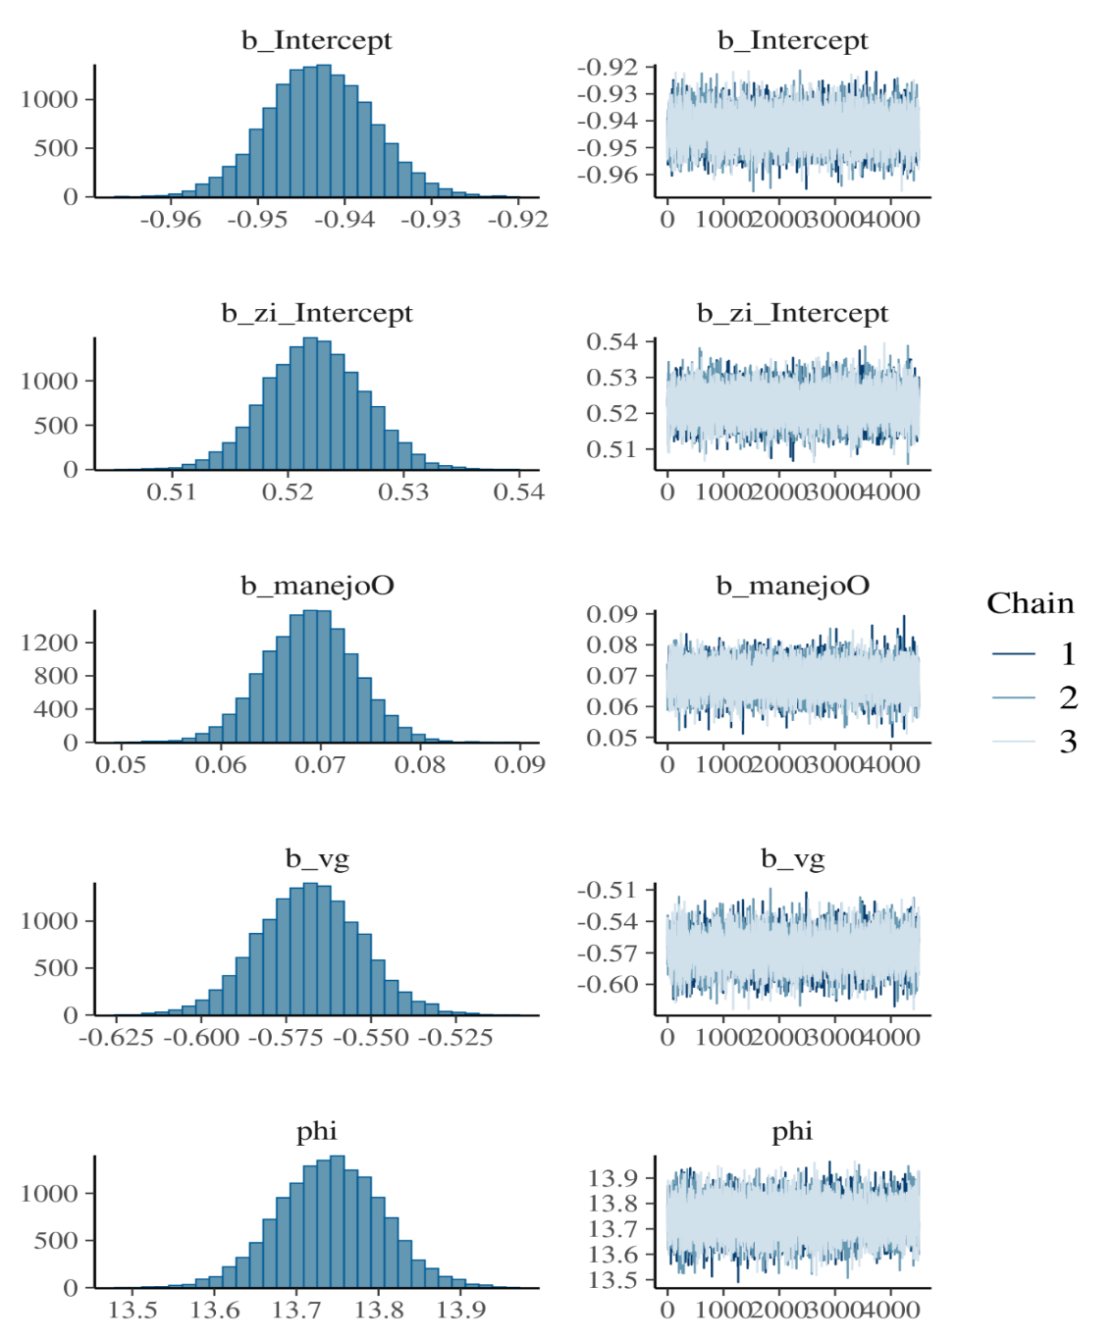

**Fig. S2:** Posterior distributions (left) and trace plots (right) for the model parameters for selected loci in *Calomys laucha*. The trace plots show the MCMC sampling behavior across iterations. All parameters exhibit good mixing and convergence (R̂ ≈ 1, high effective sample sizes).

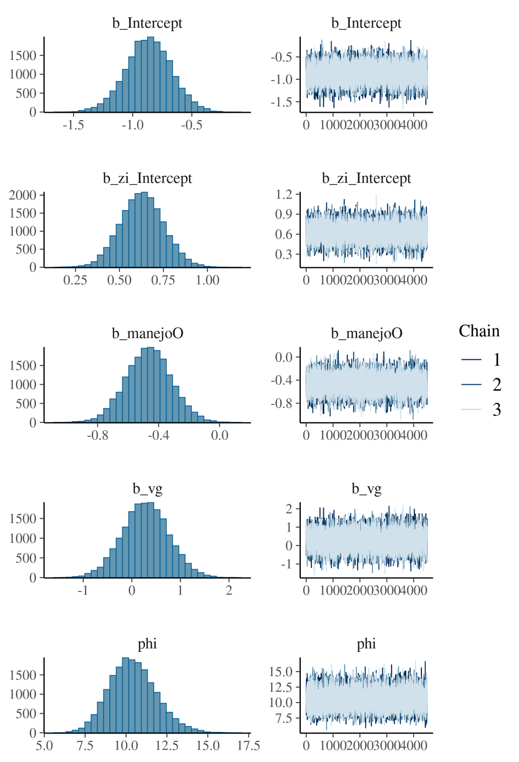

**Table S8:** Summary of the posterior parameter estimates from the Bayesian model for **neutral loci** in ***Akodon azarae****.* For each parameter, the posterior mean (estimate), standard error, and 95% credible intervals (CI) and the Gelman-Rubin statistic (R-hat), Bulk Effective Sample Size (Bulk ESS) and Tail Effective Sample Size (Tail ESS) are provided.

|  |  |  |  |  |  |  |  |
| --- | --- | --- | --- | --- | --- | --- | --- |
|  | **Estimate** | **Est.Error** | **l-95% CI** | **u-95% CI** | **Rhat** | **Bulk ESS** | **Tail ESS** |
| **Intercept** | 0.674 | 0.015 | 0.645 | 0.703 | 1.005 | 1203.812 | 1261.382 |
| **zi intercept** | 0.530 | 0.003 | 0.525 | 0.535 | 1.001 | 2280.928 | 1439.613 |
| **Organic management** | 0.115 | 0.003 | 0.109 | 0.122 | 1.001 | 1645.684 | 1603.142 |
| **vv** | -4.339 | 0.041 | -4.419 | -4.258 | 1.006 | 1143.419 | 1205.854 |

**Table S9:** Summary of the posterior parameter estimates from the Bayesian model for selected loci in *Akodon azarae.* For each parameter, the posterior mean (estimate), standard error, and 95% credible intervals (CI) and the Gelman-Rubin statistic (R-hat), Bulk Effective Sample Size (Bulk ESS) and Tail Effective Sample Size (Tail ESS) are provided.

|  |  |  |  |  |  |  |  |
| --- | --- | --- | --- | --- | --- | --- | --- |
|  | **Estimate** | **Est.Error** | **l-95% CI** | **u-95% CI** | **Rhat** | **Bulk ESS** | **Tail ESS** |
| **Intercept** | 0.393 | 0.322 | -0.242 | 1.030 | 1.000 | 17289.794 | 10239.283 |
| **zi Intercept** | 0.991 | 0.074 | 0.847 | 1.139 | 1.001 | 16656.894 | 10519.674 |
| **Organic management** | 0.294 | 0.073 | 0.152 | 0.437 | 1.000 | 16275.492 | 10991.126 |
| **vv** | -4.323 | 0.882 | -6.057 | -2.572 | 1.000 | 17092.842 | 10765.720 |

**Fig. S3:** Posterior distributions (left) and trace plots (right) for the model parameters for neutral loci in *Akodon azarae*. The trace plots show the MCMC sampling behavior across iterations. All parameters exhibit good mixing and convergence (R̂ ≈ 1, high effective sample sizes).

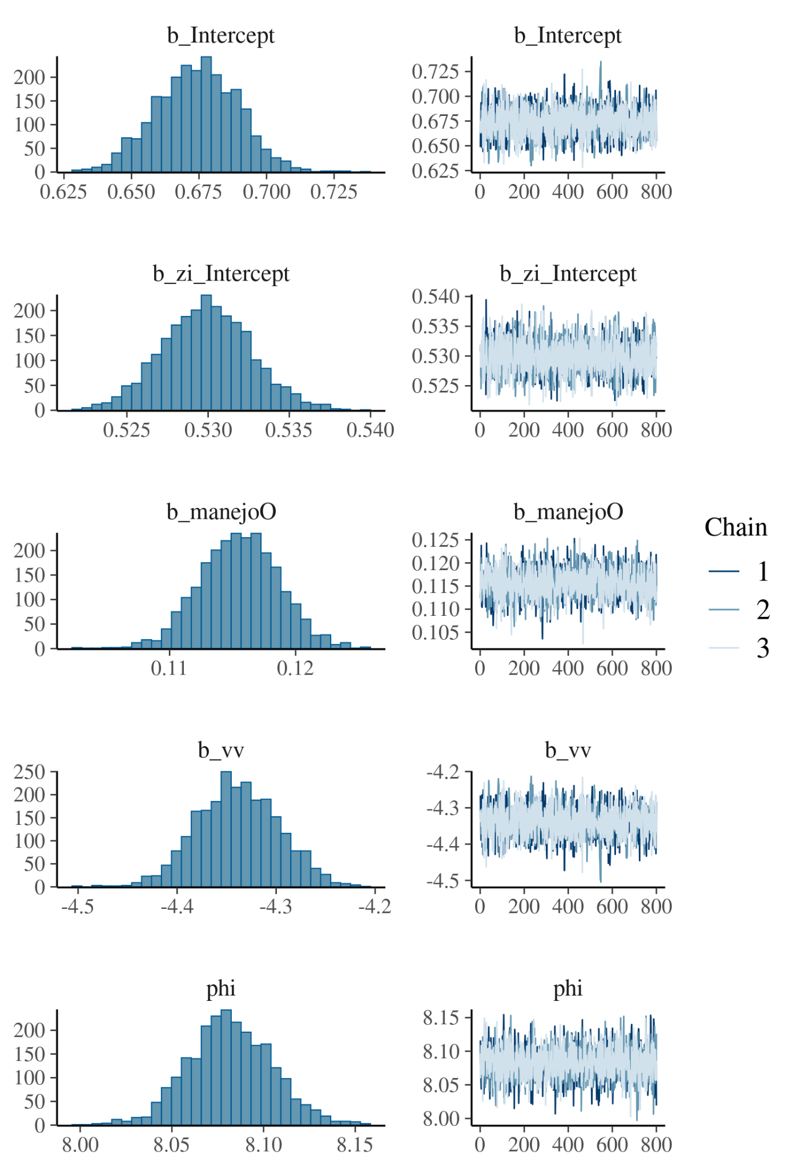

**Fig. S4:** Posterior distributions (left) and trace plots (right) for the model parameters for selected loci in *Akodon azarae*. The trace plots show the MCMC sampling behavior across iterations. All parameters exhibit good mixing and convergence (R̂ ≈ 1, high effective sample sizes).

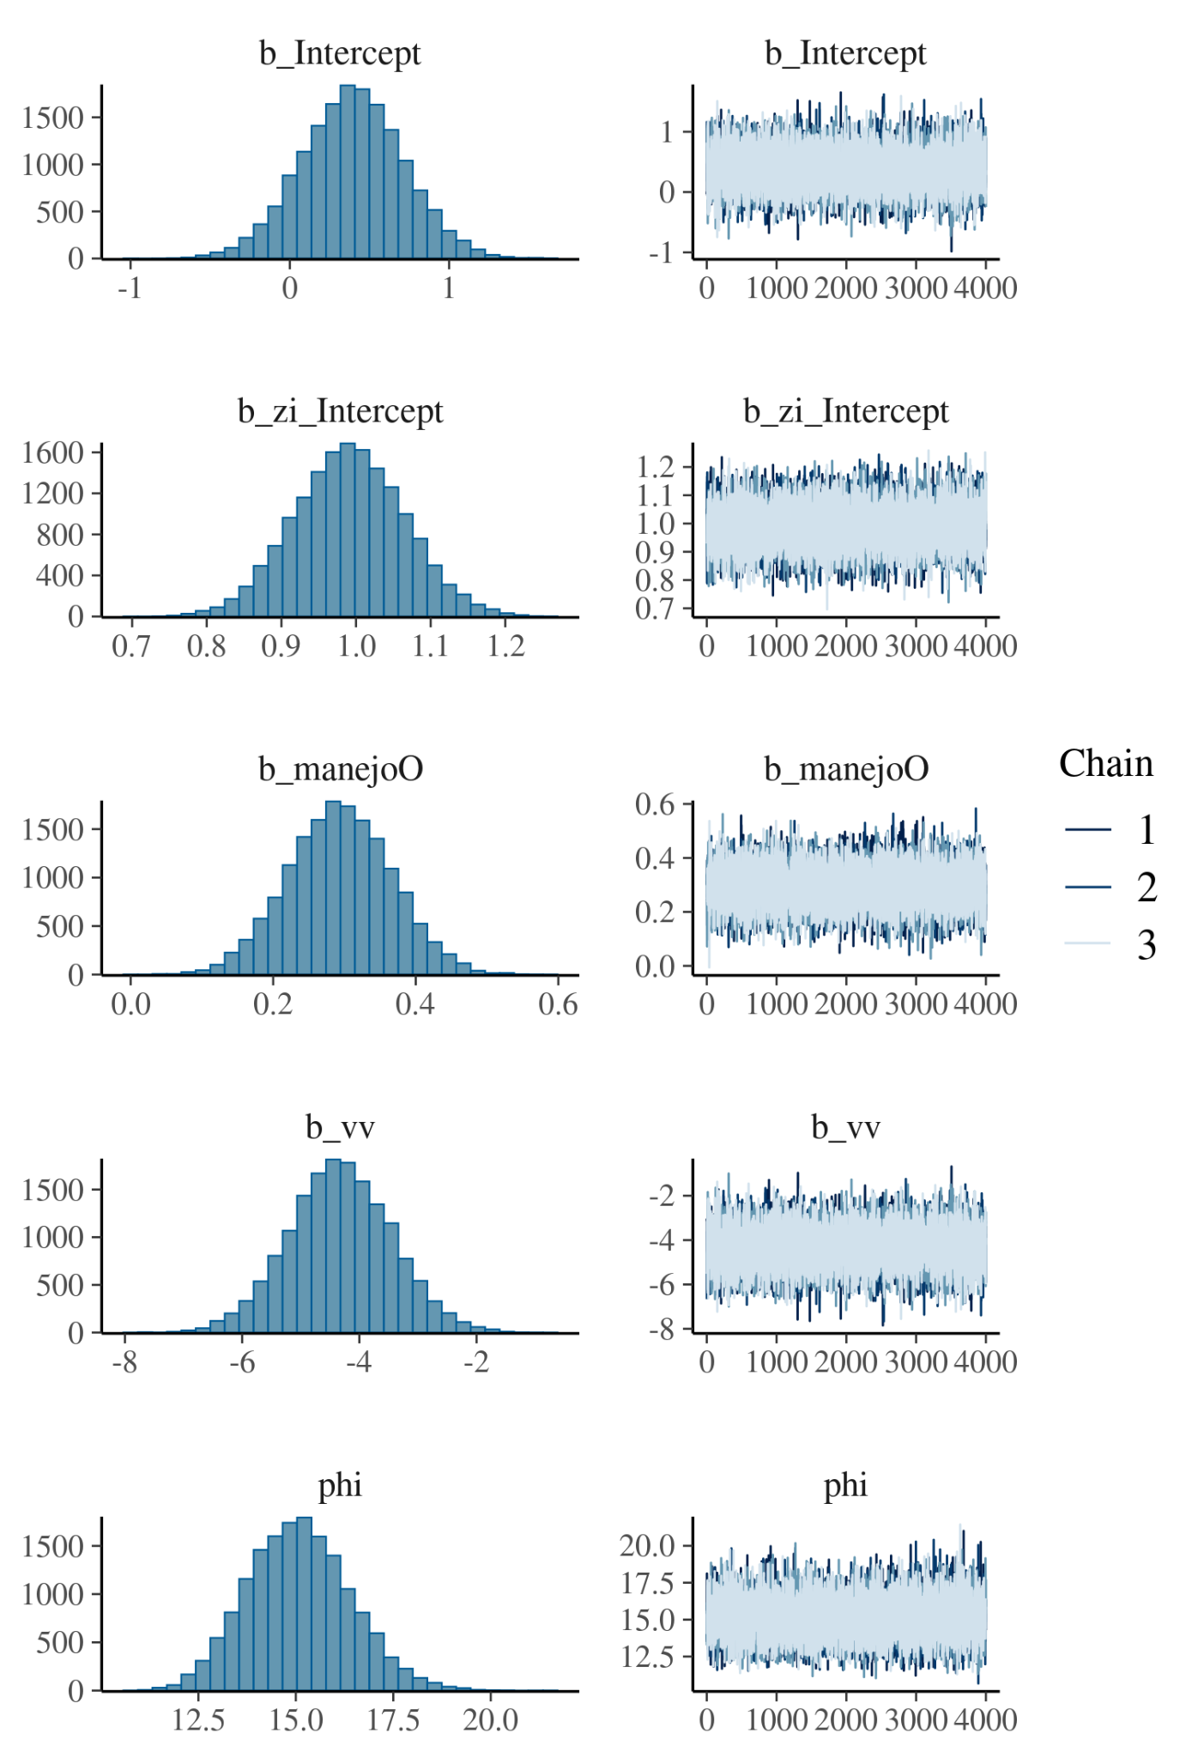

**Homozygosity by locus (HL, an individual-based estimator of genetic variability) and diagnostic statistics**

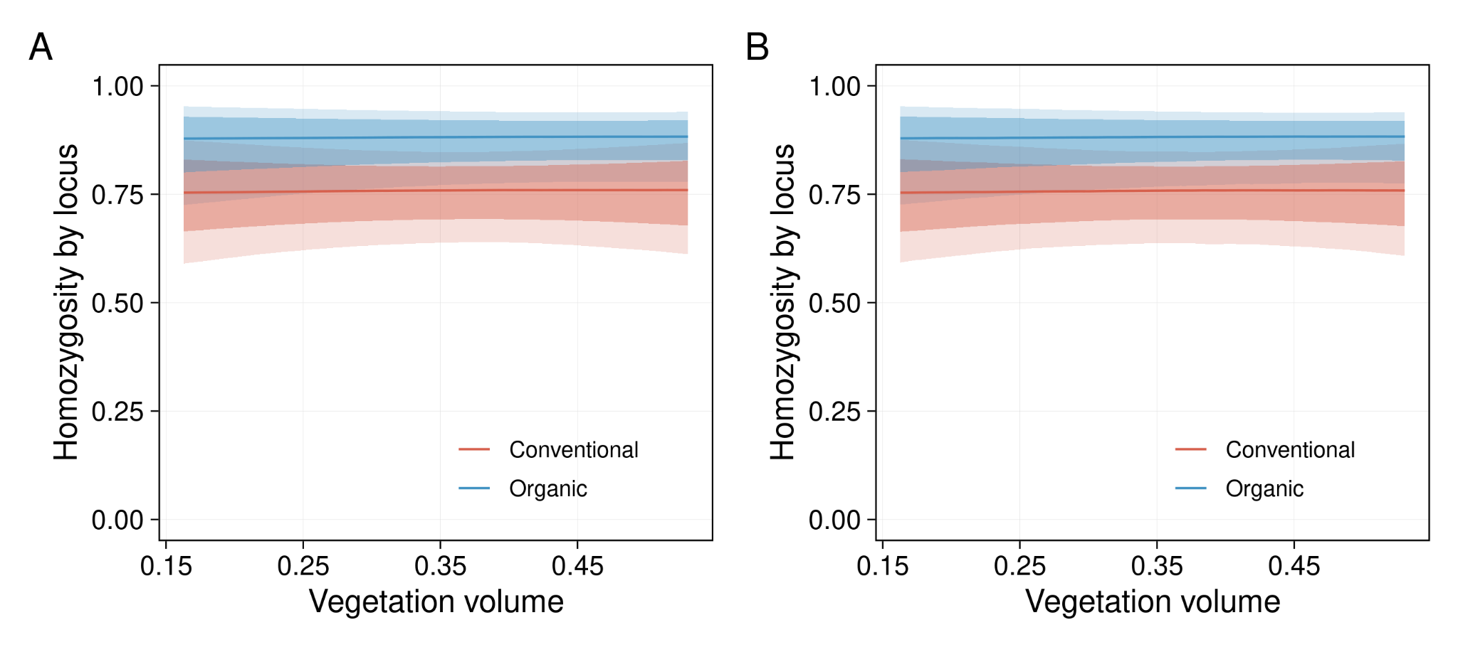

**Fig S5.** Relationship between vegetation volume and homozygosity by loci (HL) in *Calomys laucha*. (A) Neutral loci and (B) selected loci. Lines represent posterior means from Bayesian beta regression models, with light shaded areas indicating 95% credible intervals and dark shaded bands the 75% credible intervals.

**Table S10:** Summary of the posterior parameter estimates from the Homozygosity by locus for neutral loci in *Calomys laucha.* For each parameter, the posterior mean (estimate), standard error, and 95% credible intervals (CI) and the Gelman-Rubin statistic (R-hat), Bulk Effective Sample Size (Bulk ESS) and Tail Effective Sample Size (Tail ESS) are provided.

|  |  |  |  |  |  |  |  |
| --- | --- | --- | --- | --- | --- | --- | --- |
|  | **Estimate** | **Est.Error** | **l-95% CI** | **u-95% CI** | **Rhat** | **Bulk ESS** | **Tail ESS** |
| **Intercept** | 1.271 | 0.614 | 0.123 | 2.526 | 1.000 | 29415.954 | 23894.250 |
| **zi Intercept** | -3.887 | 1.294 | -6.958 | -1.946 | 1.000 | 22099.475 | 13885.068 |
| **Organic management** | 1.027 | 0.419 | 0.176 | 1.833 | 1.000 | 22601.454 | 22314.507 |
| **vv** | 0.076 | 1.482 | -2.900 | 2.915 | 1.000 | 23841.277 | 24359.190 |

**Table S11:** Summary of the posterior parameter estimates from the Homozygosity by locus for selected loci in *Calomys laucha.* For each parameter, the posterior mean (estimate), standard error, and 95% credible intervals (CI) and the Gelman-Rubin statistic (R-hat), Bulk Effective Sample Size (Bulk ESS) and Tail Effective Sample Size (Tail ESS) are provided.

|  |  |  |  |  |  |  |  |
| --- | --- | --- | --- | --- | --- | --- | --- |
|  | **Estimate** | **Est.Error** | **l-95% CI** | **u-95% CI** | **Rhat** | **Bulk_ESS** | **Tail_ESS** |
| **Intercept** | 1.274 | 0.616 | 0.118 | 2.536 | 1.000 | 12343.596 | 9724.855 |
| **zi Intercept** | -3.914 | 1.323 | -7.048 | -1.947 | 1.000 | 8392.683 | 5303.113 |
| **Organic management** | 1.0280 | 0.420 | 0.182 | 1.846 | 1.000 | 10039.017 | 9826.587 |
| **vv** | 0.0568 | 1.481 | -2.949 | 2.931 | 1.000 | 10651.840 | 9674.367 |

**Fig. S6:** Posterior distributions (left) and trace plots (right) for the homozygosity model parameters for neutral loci in *Calomys laucha*. The trace plots show the MCMC sampling behavior across iterations. All parameters exhibit good mixing and convergence (R̂ ≈ 1, high effective sample sizes).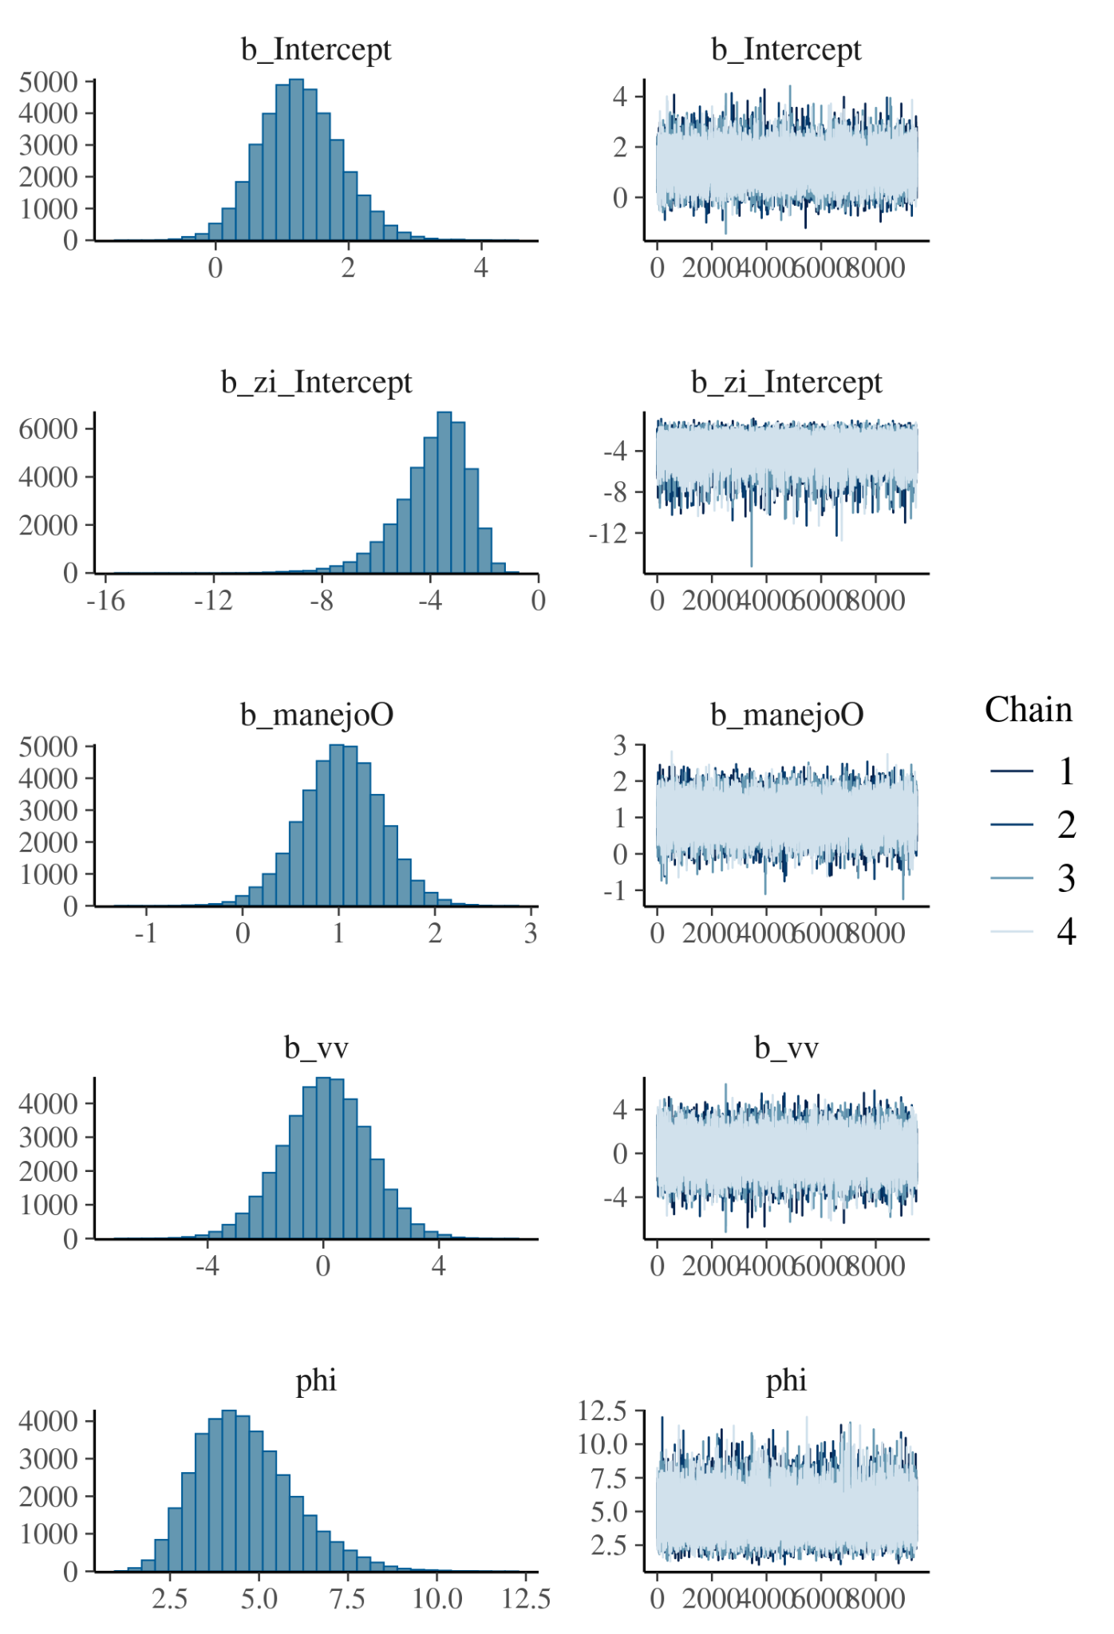

**Fig. S7:** Posterior distributions (left) and trace plots (right) for the homozygosity model parameters for selected loci in *Calomys laucha*. The trace plots show the MCMC sampling behavior across iterations. All parameters exhibit good mixing and convergence (R̂ ≈ 1, high effective sample sizes).

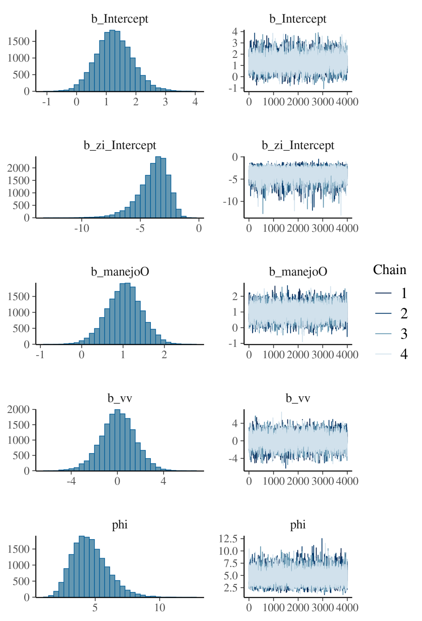

**Fig S8.** Relationship between vegetation volume and homozygosity by locus (HL) in *Akodon azarae*. (A) Neutral loci and (B) selected loci. Lines represent posterior means from Bayesian beta regression models, , with light shaded areas indicating 95% credible intervals and dark shaded bands the 75% credible intervals.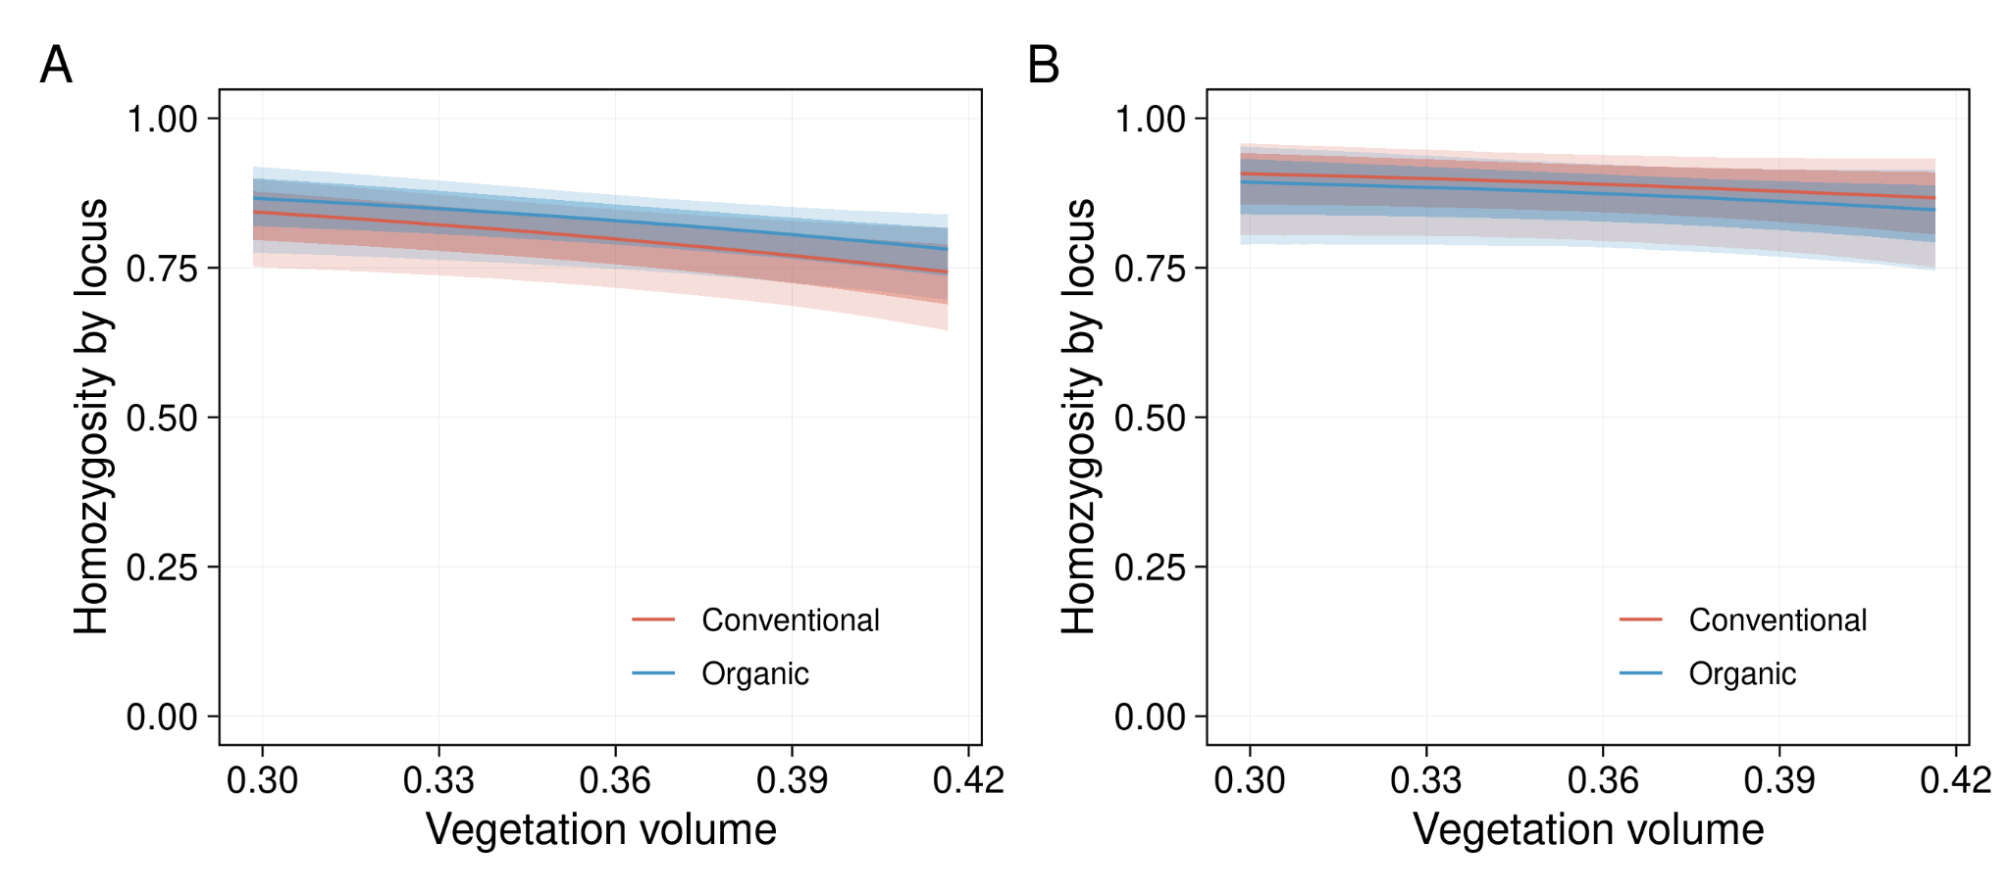

**Table S12:** Summary of the posterior parameter estimates from the Homozygosity by Locus for neutral loci in *Akodon azarae.* For each parameter, the posterior mean (estimate), standard error, and 95% credible intervals (CI) and the Gelman-Rubin statistic (R-hat), Bulk Effective Sample Size (Bulk ESS) and Tail Effective Sample Size (Tail ESS) are provided.

|  |  |  |  |  |  |  |  |
| --- | --- | --- | --- | --- | --- | --- | --- |
|  | **Estimate** | **Est.Error** | **l-95% CI** | **u-95% CI** | **Rhat** | **Bulk ESS** | **Tail ESS** |
| **Intercept** | 3.656 | 0.998 | 1.716 | 5.6327 | 1.000 | 12236.927 | 8704.558 |
| **zi intercept** | -3.982 | 1.321 | -7.116 | -2.036 | 1.000 | 11578.214 | 6682.045 |
| **Organic management** | 0.227 | 0.198 | -0.168 | 0.618 | 1.000 | 11123.495 | 9772.992 |
| **vv** | -5.922 | 2.737 | -11.454 | -0.631 | 1.000 | 12138.307 | 8753.142 |

**Table S13:** Summary of the posterior parameter estimates from the Homozygosity by locus for selected loci in *Akodon azarae.* For each parameter, the posterior mean (estimate), standard error, and 95% credible intervals (CI) and the Gelman-Rubin statistic (R-hat), Bulk Effective Sample Size (Bulk ESS) and Tail Effective Sample Size (Tail ESS) are provided.

|  |  |  |  |  |  |  |  |
| --- | --- | --- | --- | --- | --- | --- | --- |
|  | **Estimate** | **Est.Error** | **l-95% CI** | **u-95% CI** | **Rhat** | **Bulk ESS** | **Tail ESS** |
| **Intercept** | 4.022 | 1.679 | 0.787 | 7.412 | 1.000 | 12786.800 | 10689.188 |
| **zi Intercept** | -3.989 | 1.323 | -7.196 | -2.023 | 1.000 | 8883.941 | 5139.558 |
| **Organic Management** | -0.1975 | 0.342 | -0.883 | 0.471 | 1.000 | 14264.174 | 9888.976 |
| **vv** | -4.538 | 4.571 | -13.696 | 4.075 | 1.000 | 12877.317 | 10671.955 |

**Fig. S9:** Posterior distributions (left) and trace plots (right) for the homozygosity model parameters for selected loci in *Akodon azarae*. The trace plots show the MCMC sampling behavior across iterations. All parameters exhibit good mixing and convergence (R̂ ≈ 1, high effective sample sizes).

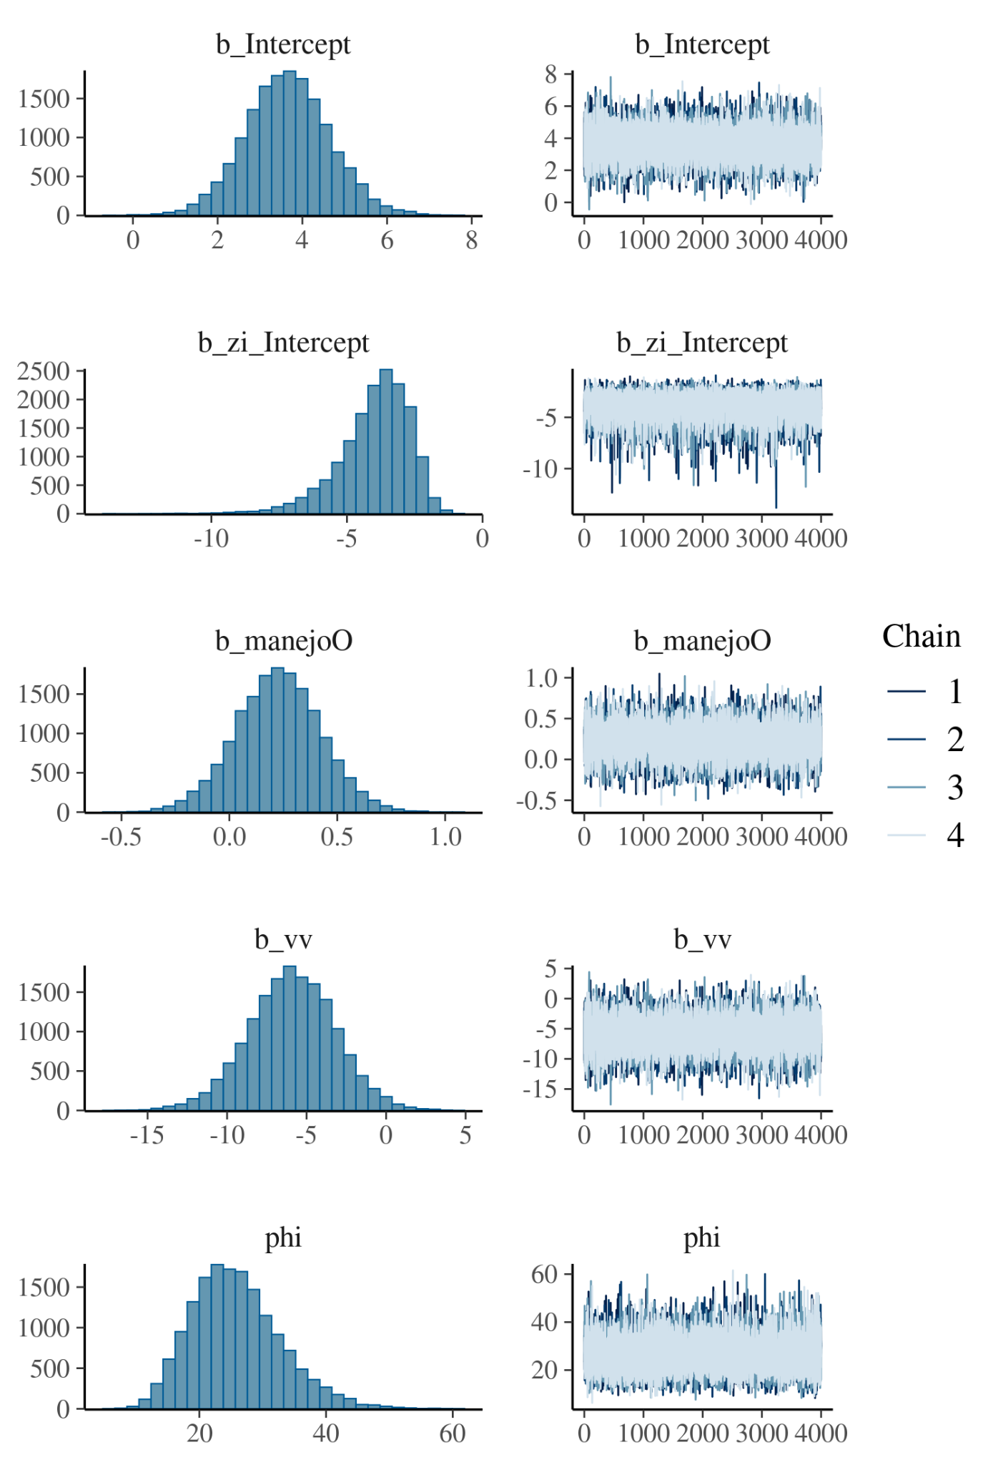

**Fig. 10:** Posterior distributions (left) and trace plots (right) for the homozygosity model parameters for selected loci in *Akodon azarae*. The trace plots show the MCMC sampling behavior across iterations. All parameters exhibit good mixing and convergence (R̂ ≈ 1, high effective sample sizes).