SOUTHERN HEMISPHERE SUMMER 2008-2009:
SOYBEAN GROWING SEASON CAMPAIGN

Crop: Soybean (Glycine max)
Type of sowing: no-till farming
Maturity group: III large
Growth type: indeterminate
Micrometeorological measurement start: January 1, 2009
Micrometeorological measurement finish: April 3, 2009
Row distance: 37cm (0.37m)
Nearest surface weather station: INTA Balcarce
Distance between this weather station and field campaign site: 1 km
The crop was grown in rainfed conditions.
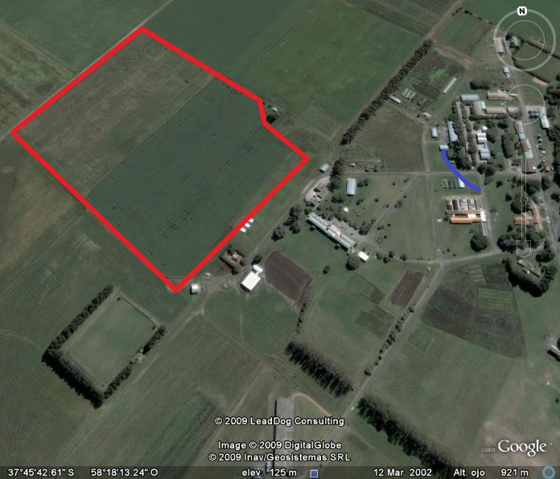
Google Earth crop plot of 25 ha. E and SW side of the plot: double line of Eucalyptus trees of 20 m height. Site location: 37°45'34.37"S 58°18'22.5"W, District of Balcarce, Buenos Aires, Argentina.

Air measurements
Tower height: 5 m
Measurement methodology: Profile
Number of profile method levels: 4

Variable | Name | Units | Observ. Freq. | Measurement level (m) | Equipment
Wind direction  Wind velocity | DIR  VEL | º | L | 1.10; 1.70; 2.65; 4.16 | RM 05103 Young Wind Monitor
Wind direction  Wind velocity | DIR  VEL | m s⁻¹ | L | 1.10; 1.70; 2.65; 4.16 | RM 05103 Young Wind Monitor
Air temperature | TA | °C | L | 1.10; 1.70; 2.65; 4.16 | Vaisala HMP45  Vaisala HMP35
Canopy air temperature | TC | °C | L | 0.30 | Vaisala HMP35
Air humidity (relative) | HR | % | L | 1.10; 1.70; 2.65; 4.16 | Vaisala HMP45  Vaisala HMP35
Canopy air humidity | HRC | % | L | 0.30 | Vaisala HMP35
Soil heat flux (plates) | FLUX | W m⁻² | L | -0.10 | HFT-3 REBS Soil heat flux plate
Soil temperature | TS | °C | L | -0.05 | T- Type Thermocouple - Omega Engineering
Global radiation | RG | W m⁻² | L | 2.10 | LI-COR 200 Pyranometer
Net radiation | RN1  RN2 | W m⁻² | L | 2.10  2.10 | Middleton – Net radiometer  REBS Q7.1 Net radiometer
Dataloggers |  |  | H, L |  | Campbell Scientific Inc. 21X, Multiplexer
Observ. L 1 sample every 30 seconds, 15 minutes averaging.

DS: standard deviation of each variable

Tower sensor measurement height (a.g.l) identification:
- Level 1: 1.10 m
- Level 2: 1.70 m
- Level 3: 2.65 m
- Level 4: 4.16 m

Soil surface temperature measurement depth identification:
● thermocouple 0.005 m, 2 repetitions, instrumental averaging of 4 point measurements each.

Other information
- Frequency of soil water content measurements with neutron probe: once per week
- Plant height measurement frequency: once per week

