METADATA FIEL CAMPAIGN MAR CHIQUITA Argentina

- Site name: MARCHI CELPA
- Site: Salt Marsh near the Mar Chiquita Lagoon. Buenos Aires province.
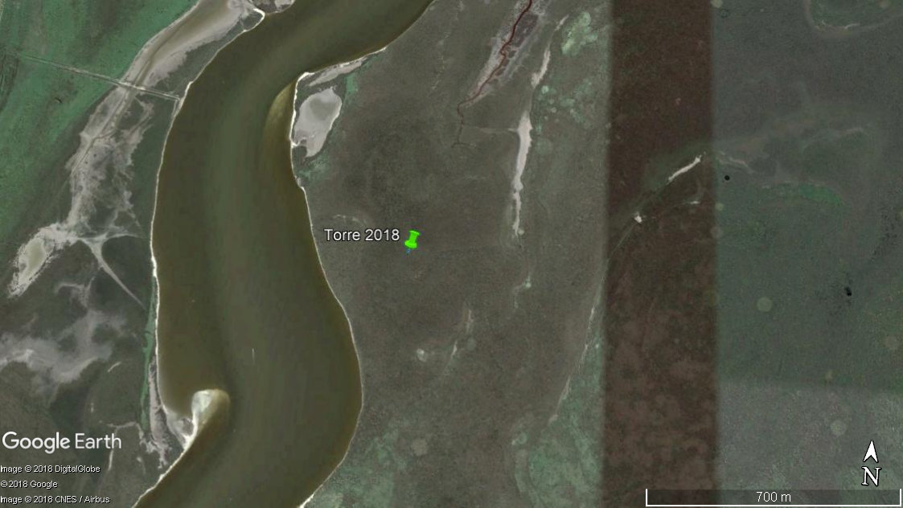
- Geographic location: GPS 37° 42.171’ S; 57° 25.152’ O
- Sensor distribution in the field (plan view):
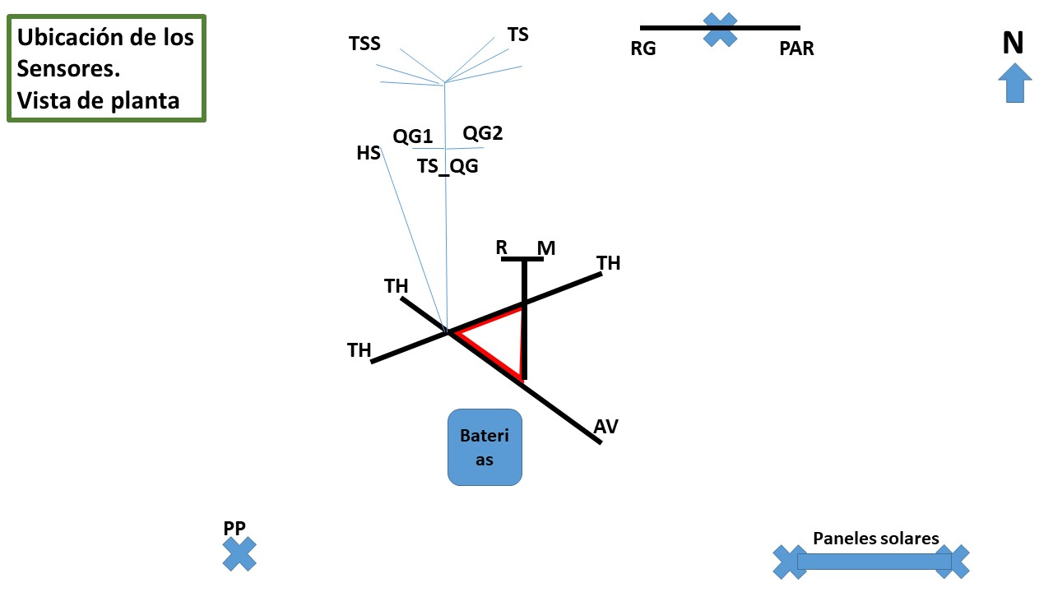

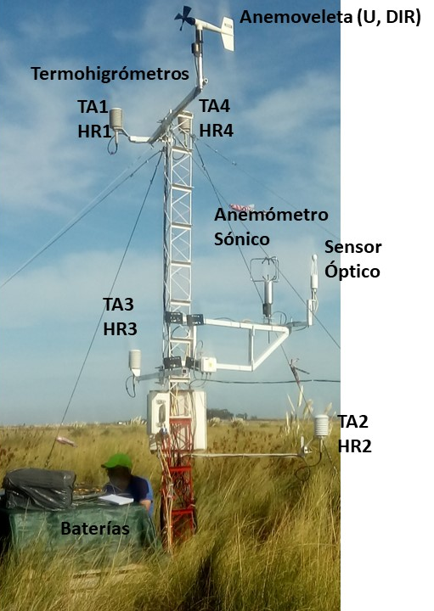

- Sensors, variables, units and height or depth of measurements
Tabla 1: Low frequency measurements (15 minutes). In yellow: sensors not working any more.
Sensor  Model/Brand | Identifier | Variable | Unit | Height (+) or depth (-) (m)
Termocuple  K-type | TSS1 | Soil surface temperature | °C | -0.005
Termocuple  K-type | TSS2 | Soil surface temperature | °C | -0.005
Termocuple  K-type | TS1 | Soil temperature | °C | -0.03
Termocuple  K-type | TS2 | Soil temperature | °C | -0.08
Termocuple  K-type | TS3 | Soil temperature | °C | -0.27
Termocuple  K-type | TS4 | Soil temperature | °C | -0.70
Hukseflux Termocuple  T-type | TS_QG | Soil temperature | °C | -0.05
RM Young  Windvane Monitor | U  DIR | Mean wind speed  Wind direction | m s⁻¹  ° | 4.20
Rain gauge Texas Electronics  TE525WS | PP | Rain depth | mm | 2.0
Temperature/RH probe  Vaisala HMP60 | TA  HR | Air temperature and relative humidity | °C  % | 4.1
Soil heat flux plate  Hukseflux | QG | Soil heat flux plates | W m⁻² | -0.1
Wetness | WET | Wetness | Ohm | 1.5
Quantic Sensor PAR  LiCor Li190 | PAR | Photosynthetic active radiation | μmol m⁻² s⁻¹ | 2.0

Tabla 2: High frequency measurements (20 Hz)
Sensor  Model/Brand | Identifier | Variable | Unit | Sensor height (m)
3D Sonic anemometer  Young 81000 | u, v, w  Tson | Wind vector components  Virtual sonic temperature | m s⁻¹  °C | 2.9
Open Path IRGA gas analyzer  LiCor Li7500A | CO2; a  p | CO2 and H2O concentrations  Atmospheric pressure | mmol m⁻³; g m⁻³  hPa | 2.9

- Turbulent variables
Data processing with TK3 software. Mauder, M. and Foken, T. 2015. Documentation and Instruction Manual of the Eddy-Covariance Software Package TK3 (update). Universität Bayreuth, Abt. Mikrometeorologie. Arbeitsergebnisse Nr. 62 Bayreuth. 67 pp.

Micrometeorological coordinate system is considered (Stull, 1988)
Friction velocity: u_star (m s⁻¹)
Stability parameter: z/L, L: Obukhov length (m); z/Lvir, Lvir Obukhov length corrected by air humidity content
Fluxes: sensible heat – H (W m⁻²), latent heat – LvE (W m⁻²), carbon flux – NEE (mmol m⁻² s⁻¹), stored carbon flux between surface and sensor – FCstored (mmol m⁻² s⁻¹)

Turbulent flux measurements were interrupted on March 21, 2018, due to an optical sensor failure.
The measurement campaign was suspended on March 2020, due to the SARS-CoV-2 pandemic.

- Power supply:
2 solar panels 40 W
2 solar panels 35 W
6 deep cycle batteries 12 V, 110 Ah

- Monthly measurements
- Soil water content by gravimetric method
- Aerial biomass (Green and death)
- Surface canopy height (only Spartina densiflora)
- Spartina densiflora coverage
Floristic catalog:
Spartina densiflora, Sarcocornia ambigua, Juncus acutus, Hydrocotyle bonariensis , Pluchea sagittalis, Conyza floribunda
- Water table depth

