
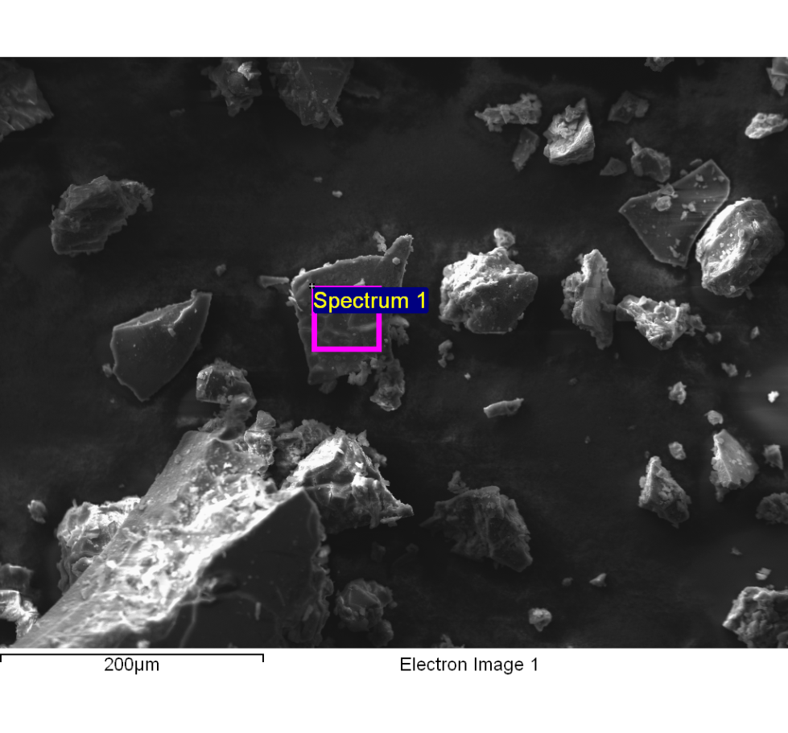
Spectrum processing :
Peaks possibly omitted : 7.491, 8.037, 9.700, 11.483 keV

Processing option : All elements analyzed (Normalised)
Number of iterations = 6

Standard :
C CaCO3 1-Jun-1999 12:00 AM
O SiO2 1-Jun-1999 12:00 AM
Na Albite 1-Jun-1999 12:00 AM
Mg MgO 1-Jun-1999 12:00 AM
Al Al2O3 1-Jun-1999 12:00 AM
Si SiO2 1-Jun-1999 12:00 AM
S FeS2 1-Jun-1999 12:00 AM
Cl KCl 1-Jun-1999 12:00 AM
K MAD-10 Feldspar 1-Jun-1999 12:00 AM
Ca Wollastonite 1-Jun-1999 12:00 AM
Fe Fe 1-Jun-1999 12:00 AM

Element | Weight% | Atomic%
C K | 47.09 | 58.77
O K | 32.20 | 30.17
Na K | 10.21 | 6.66
Mg K | 0.66 | 0.41
Al K | 0.10 | 0.06
Si K | 0.09 | 0.05
S K | 0.76 | 0.35
Cl K | 3.59 | 1.52
K K | 4.65 | 1.78
Ca K | 0.53 | 0.20
Fe K | 0.11 | 0.03
Totals | 100.00

Comment:
14/10/2022 10:09:15
Lixiviado

