
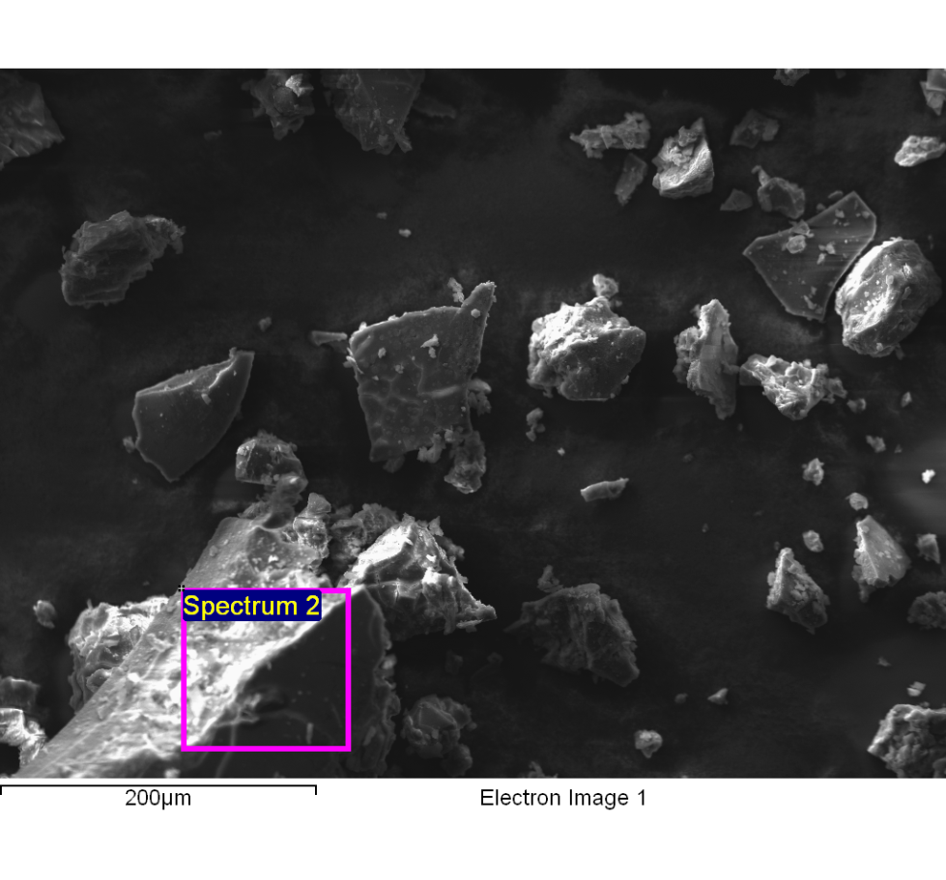
Spectrum processing :
Peaks possibly omitted : 4.490, 8.034, 9.703, 11.463 keV

Processing option : All elements analyzed (Normalised)
Number of iterations = 5

Standard :
C CaCO3 1-Jun-1999 12:00 AM
N Not defined 1-Jun-1999 12:00 AM
O SiO2 1-Jun-1999 12:00 AM
Na Albite 1-Jun-1999 12:00 AM
Mg MgO 1-Jun-1999 12:00 AM
Al Al2O3 1-Jun-1999 12:00 AM
Si SiO2 1-Jun-1999 12:00 AM
P GaP 1-Jun-1999 12:00 AM
S FeS2 1-Jun-1999 12:00 AM
Cl KCl 1-Jun-1999 12:00 AM
K MAD-10 Feldspar 1-Jun-1999 12:00 AM
Ca Wollastonite 1-Jun-1999 12:00 AM
Fe Fe 1-Jun-1999 12:00 AM

Element | Weight% | Atomic%
C K | 36.15 | 52.11
N K | -0.92 | -1.14
O K | 26.40 | 28.57
Na K | 7.79 | 5.87
Mg K | 1.20 | 0.85
Al K | 0.13 | 0.08
Si K | 0.36 | 0.22
P K | 0.28 | 0.16
S K | 0.17 | 0.09
Cl K | 14.22 | 6.94
K K | 10.86 | 4.81
Ca K | 3.22 | 1.39
Fe K | 0.15 | 0.05
Totals | 100.00

Comment:
14/10/2022 10:17:49
Lixiviado

