
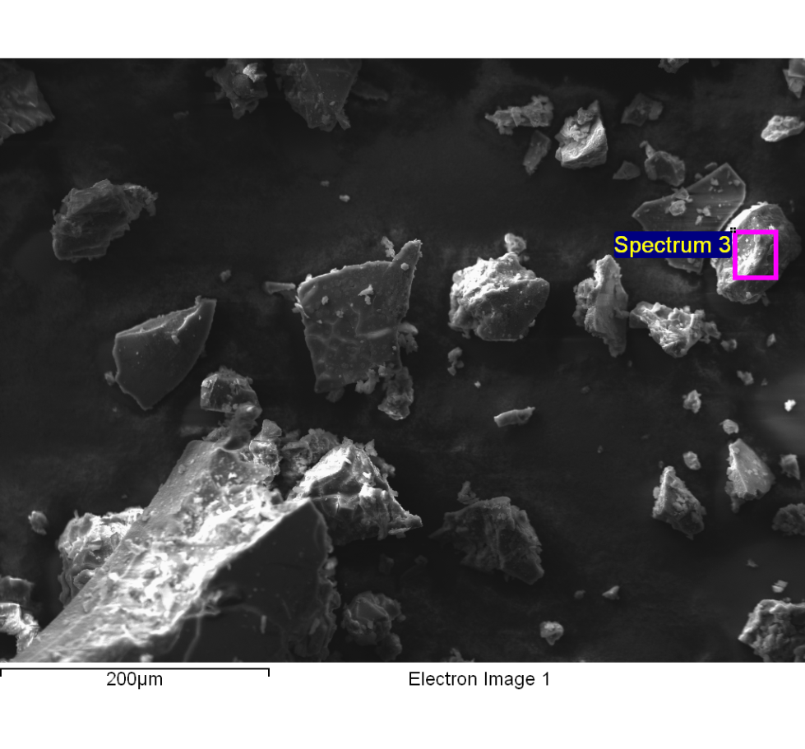
Spectrum processing :
Peaks possibly omitted : 5.256, 5.956, 6.400, 6.611, 8.045, 9.698, 10.869, 11.469 keV

Processing option : All elements analyzed (Normalised)
Number of iterations = 6

Standard :
C CaCO3 1-Jun-1999 12:00 AM
N Not defined 1-Jun-1999 12:00 AM
O SiO2 1-Jun-1999 12:00 AM
Na Albite 1-Jun-1999 12:00 AM
Al Al2O3 1-Jun-1999 12:00 AM
S FeS2 1-Jun-1999 12:00 AM
Cl KCl 1-Jun-1999 12:00 AM
K MAD-10 Feldspar 1-Jun-1999 12:00 AM

Element | Weight% | Atomic%
C K | 39.90 | 57.79
N K | 2.32 | 2.88
O K | 18.22 | 19.82
Na K | 3.28 | 2.48
Al K | 0.08 | 0.05
S K | 0.11 | 0.06
Cl K | 18.78 | 9.21
K K | 17.31 | 7.70
Totals | 100.00

Comment:
14/10/2022 10:29:15
Lixiviado

