
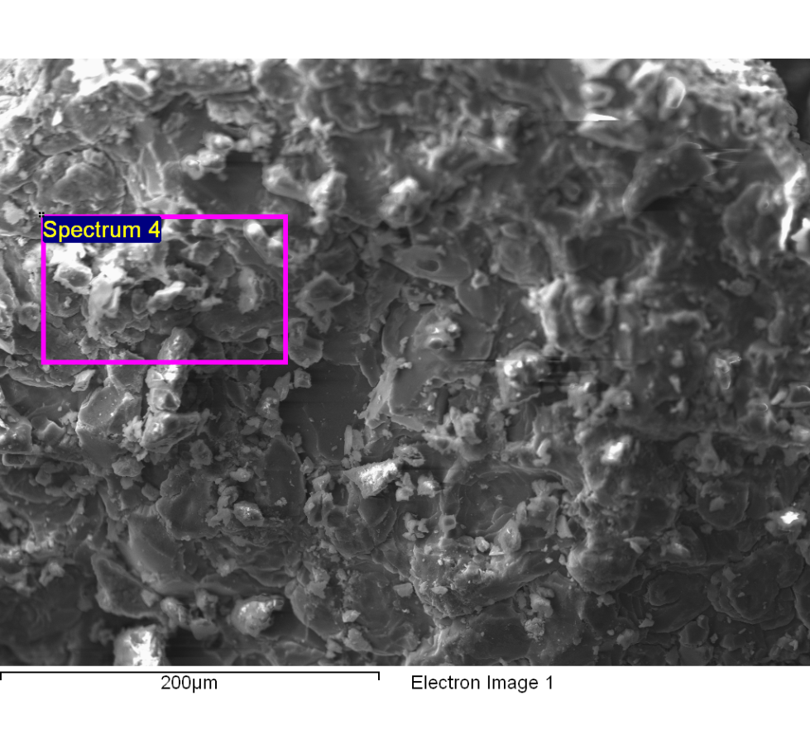
Spectrum processing :
Peaks possibly omitted : 5.254, 9.698, 11.509, 12.595 keV

Processing option : All elements analyzed (Normalised)
Number of iterations = 5

Standard :
C CaCO3 1-Jun-1999 12:00 AM
N Not defined 1-Jun-1999 12:00 AM
O SiO2 1-Jun-1999 12:00 AM
Na Albite 1-Jun-1999 12:00 AM
Mg MgO 1-Jun-1999 12:00 AM
Al Al2O3 1-Jun-1999 12:00 AM
Si SiO2 1-Jun-1999 12:00 AM
P GaP 1-Jun-1999 12:00 AM
S FeS2 1-Jun-1999 12:00 AM
Cl KCl 1-Jun-1999 12:00 AM
K MAD-10 Feldspar 1-Jun-1999 12:00 AM
Ca Wollastonite 1-Jun-1999 12:00 AM
Fe Fe 1-Jun-1999 12:00 AM

Element | Weight% | Atomic%
C K | 37.20 | 53.95
N K | -0.83 | -1.03
O K | 21.31 | 23.21
Na K | 12.26 | 9.29
Mg K | 0.64 | 0.46
Al K | 0.07 | 0.05
Si K | 0.19 | 0.12
P K | 0.05 | 0.03
S K | 0.06 | 0.03
Cl K | 21.68 | 10.65
K K | 6.04 | 2.69
Ca K | 1.24 | 0.54
Fe K | 0.09 | 0.03
Totals | 100.00

Comment:
14/10/2022 10:44:56
Lixiviado

