
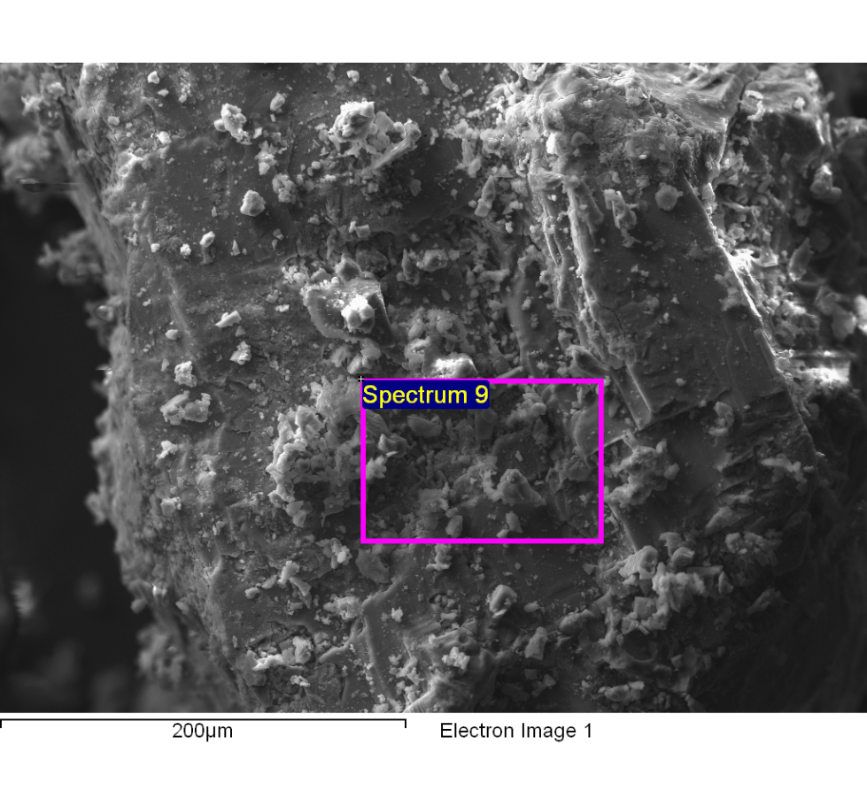
Spectrum processing :
Peaks possibly omitted : 0.775, 4.020, 5.246, 5.925, 6.399, 8.050, 9.701, 11.454, 11.610, 11.935 keV

Processing option : All elements analyzed (Normalised)
Number of iterations = 5

Standard :
C CaCO3 1-Jun-1999 12:00 AM
N Not defined 1-Jun-1999 12:00 AM
O SiO2 1-Jun-1999 12:00 AM
Na Albite 1-Jun-1999 12:00 AM
Mg MgO 1-Jun-1999 12:00 AM
Al Al2O3 1-Jun-1999 12:00 AM
S FeS2 1-Jun-1999 12:00 AM
Cl KCl 1-Jun-1999 12:00 AM
K MAD-10 Feldspar 1-Jun-1999 12:00 AM

Element | Weight% | Atomic%
C K | 28.40 | 44.82
N K | 5.18 | 7.01
O K | 15.20 | 18.00
Na K | 10.13 | 8.35
Mg K | 0.54 | 0.42
Al K | 0.24 | 0.17
S K | 1.85 | 1.09
Cl K | 29.87 | 15.97
K K | 8.59 | 4.16
Totals | 100.00

Comment:
14/10/2022 11:48:32
clarificado optimo 16

