
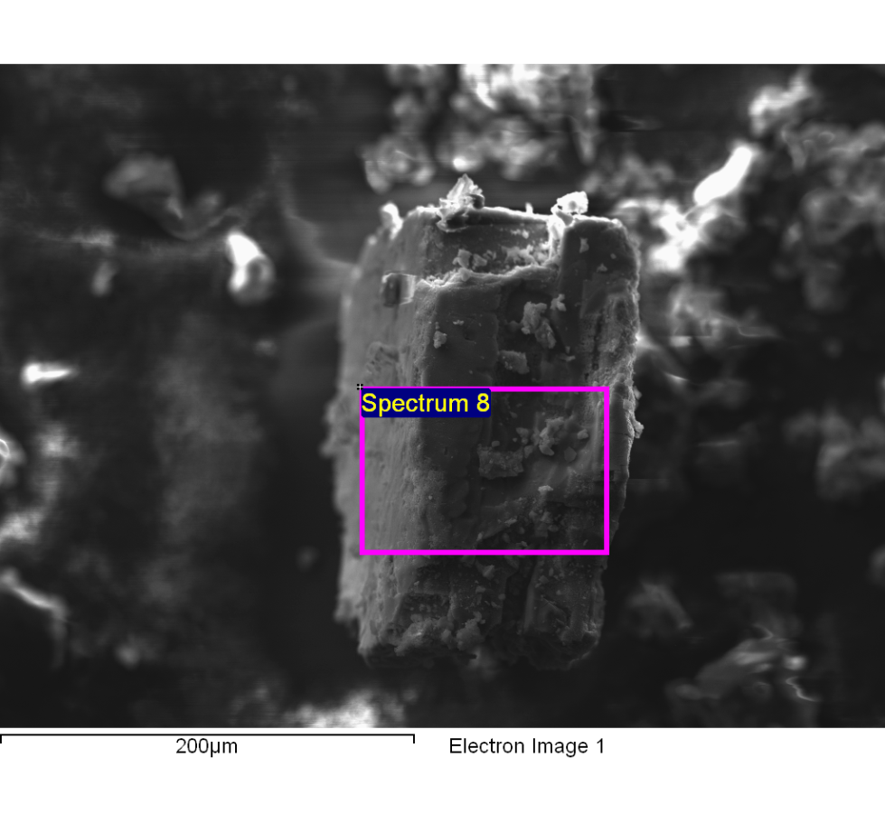
Spectrum processing :
Peaks possibly omitted : 0.770, 5.244, 5.943, 8.048, 9.702, 11.482 keV

Processing option : All elements analyzed (Normalised)
Number of iterations = 5

Standard :
C CaCO3 1-Jun-1999 12:00 AM
N Not defined 1-Jun-1999 12:00 AM
O SiO2 1-Jun-1999 12:00 AM
Na Albite 1-Jun-1999 12:00 AM
Mg MgO 1-Jun-1999 12:00 AM
Al Al2O3 1-Jun-1999 12:00 AM
S FeS2 1-Jun-1999 12:00 AM
Cl KCl 1-Jun-1999 12:00 AM
K MAD-10 Feldspar 1-Jun-1999 12:00 AM

Element | Weight% | Atomic%
C K | 38.06 | 54.07
N K | 8.71 | 10.61
O K | 16.64 | 17.75
Na K | 0.96 | 0.71
Mg K | 0.51 | 0.36
Al K | 0.12 | 0.08
S K | 1.06 | 0.56
Cl K | 23.27 | 11.20
K K | 10.68 | 4.66
Totals | 100.00

Comment:
14/10/2022 11:35:41
clarificado optimo 16

