
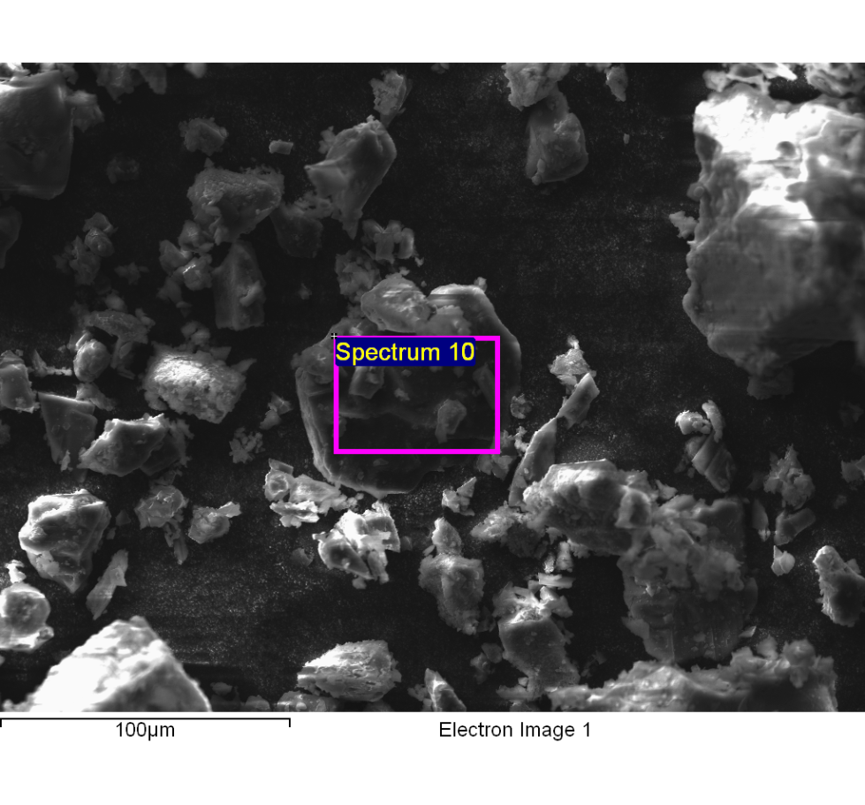
Spectrum processing :
Peaks possibly omitted : 8.066, 9.706, 11.460, 15.790 keV

Processing option : All elements analyzed (Normalised)
Number of iterations = 6

Standard :
C CaCO3 1-Jun-1999 12:00 AM
N Not defined 1-Jun-1999 12:00 AM
O SiO2 1-Jun-1999 12:00 AM
Na Albite 1-Jun-1999 12:00 AM
Mg MgO 1-Jun-1999 12:00 AM
Al Al2O3 1-Jun-1999 12:00 AM
Si SiO2 1-Jun-1999 12:00 AM
S FeS2 1-Jun-1999 12:00 AM
Cl KCl 1-Jun-1999 12:00 AM
K MAD-10 Feldspar 1-Jun-1999 12:00 AM
Ca Wollastonite 1-Jun-1999 12:00 AM
Fe Fe 1-Jun-1999 12:00 AM

Element | Weight% | Atomic%
C K | 42.96 | 55.95
N K | 2.04 | 2.28
O K | 30.28 | 29.60
Na K | 2.51 | 1.71
Mg K | 2.14 | 1.37
Al K | 1.03 | 0.60
Si K | 0.79 | 0.44
S K | 4.60 | 2.25
Cl K | 9.18 | 4.05
K K | 3.81 | 1.52
Ca K | 0.39 | 0.15
Fe K | 0.27 | 0.08
Totals | 100.00

Comment:
14/10/2022 12:02:02
clarificado optimo 16

