METADATA FIEL CAMPAIGN MAR CHIQUITA Argentina

- Site name: MARCHI ROMANO
- Site: Salt Marsh near the Mar Chiquita Lagoon. Buenos Aires province.
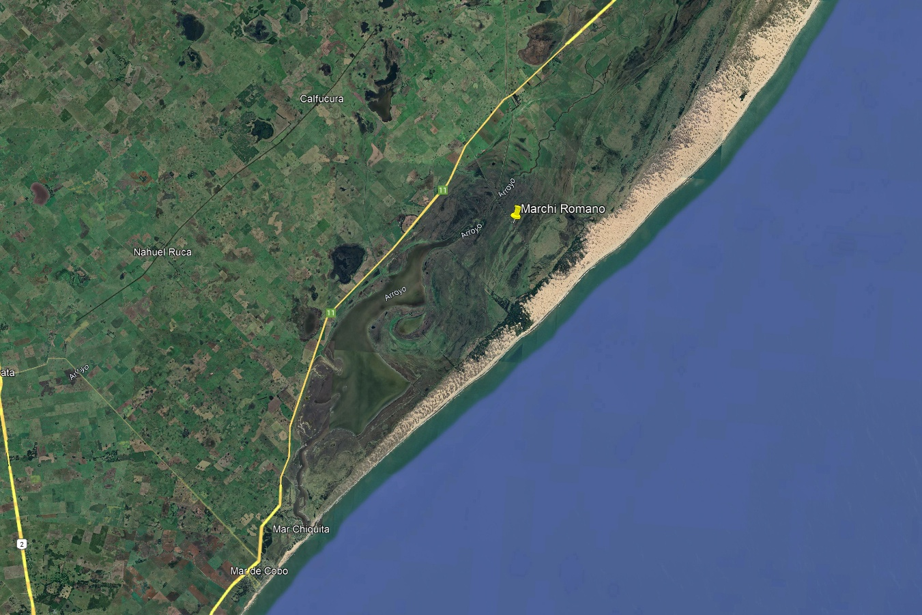
Mapa ubicación Romano con Google Earth.
- Geographic location: GPS 37° 33’ 3.07’’ S; 57° 16’ 50.38’’ O
- Site instalation:
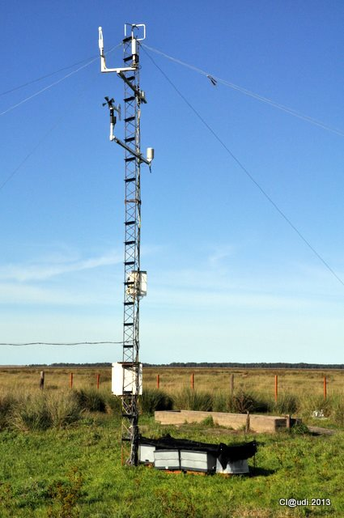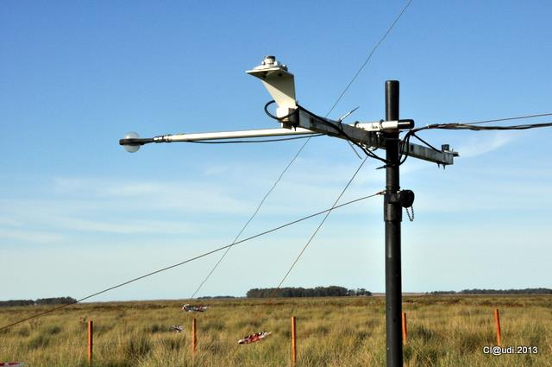

- Sensors, variables, units and height or depth of measurements
Tabla 1: Low frequency measurements (15 minutes). In yellow: sensors not working any more.
Sensor  Model/Brand | Identifier | Variable | Unit | Height (+) or depth (-) (m)
Hukseflux Termocuple  T-type | Ts | Soil surface temperature | °C | -0.005
RM Young  Windvane Monitor | U_anem  Dir_anem | Mean wind speed  Wind direction | m s⁻¹  ° | 5.0
Rain gauge Davis | PP | Rain depth | mm | 2.0
Temperature/RH probe  Vaisala HMP60 | Ta  RH | Air temperature and relative humidity | °C  % | 5.0
Soil heat flux plate  Hukseflux | G | Soil heat flux plates | W m⁻² | -0.1
Quantic Sensor PAR  LiCor Li190 | PAR | Photosynthetic active radiation | μmol m⁻² s⁻¹ | 2.0

Tabla 2: High frequency measurements (20 Hz)
Sensor  Model/Brand | Identifier | Variable | Unit | Sensor height (m)
3D Sonic anemometer  Young 81000 | u, v, w  Tson | Wind vector components  Virtual sonic temperature | m s⁻¹  °C | 6.0
Open Path IRGA gas analyzer  LiCor Li7500A | CO2; a  Pa | CO2 and H2O concentrations  Atmospheric pressure | mmol m⁻³; g m⁻³  hPa | 6.0

- Turbulent variables
Data processing with TK3 software. Mauder, M. and Foken, T. 2015. Documentation and Instruction Manual of the Eddy-Covariance Software Package TK3 (update). Universität Bayreuth, Abt. Mikrometeorologie. Arbeitsergebnisse Nr. 62 Bayreuth. 67 pp.

Micrometeorological coordinate system is considered (Stull, 1988)
Friction velocity: u_star (m s⁻¹)
Stability parameter: z/L, L: Obukhov length (m); z/Lvir, Lvir Obukhov length corrected by air humidity content
Fluxes: sensible heat – H (W m⁻²), latent heat – LvE (W m⁻²), carbon flux – NEE (mmol m⁻² s⁻¹), stored carbon flux between surface and sensor – FCstored (mmol m⁻² s⁻¹)

Site description: https://doi.org/10.1016/j.agrformet.2018.08.001

- Data and units
TIMESTAMP_START – TIMESTAMP_END: 10 digits: yyyymmddhhmm (hhmm-UTC time)
CO2: Carbon dioxide concentration (mmol m⁻³)
CO2_sigma: carbon dioxide standard deviation (mmol m⁻³)
H2O: water vapor concentration (g m⁻³)
H2O_sigma: water vapor standard deviation (g m⁻³)
T_sonic: sonic temperature (°C)
T_sonic_sigma: sonic temperature standard deviation (°C)
MO_LENGTH: Obukhov Length (m)
zL: (z/L) Stability parameter surface layer
U_sigma: u-wind component standard deviation (m/s)
V_sigma: v-wind component standard deviation (m/s)
W_sigma: w-wind component standard deviation (m/s)
NEE: net ecosystem exchange (carbon dioxide flux) (μmol m⁻² s⁻¹)
H: sensible heat flux (W m⁻²)
LE: latent heat flux (W m⁻²)
G1-G2: soil heat flux 10 cm depth (W m⁻²)
RH: relative humidity (%)
Ta: air temperature (°C) (hygrometer)
U_anem: wind speed (m/s)
Dir_anemom: wind direction (°)
PP: precipitation (mm)
Pa: atmospheric pressure (kPa)
PAR: photosynthetic active radiation (μmol m⁻² s⁻¹)
Rg: solar global radiation (W m⁻²)
TS: mean soil temperature in the [0-10 cm] depth (°C)
USTAR: friction velocity (m/s)

- Power supply:
2 solar panels 40 W
2 solar panels 35 W
6 deep cycle batteries 12 V, 110 Ah

- Monthly measurements
- Soil water content by gravimetric method
- Aerial biomass (Green and death)
- Spartina densiflora coverage
Floristic catalog:
Spartina densiflora, Sarcocornia ambigua, Juncus acutus, Hydrocotyle bonariensis , Pluchea sagittalis, Conyza floribunda

