Silica abundance
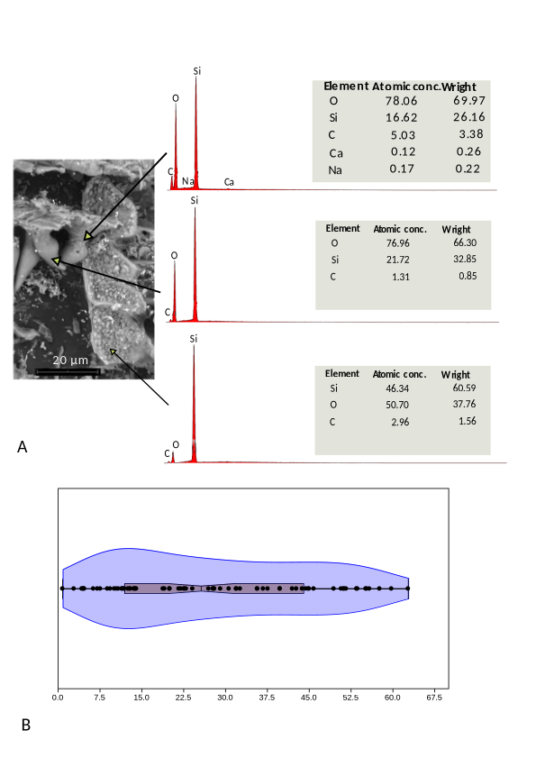
Silica abundance. A. Principal chemical elements present in different parts of the silicified elements. B. Violin plot of the different percentages of silica obtained from the processed samples.

